**Product Placement Effectiveness - Entertainment Sector**

Pooja Joshi & E.Code [E25007]

# Overview :

# The objective of this task is to evaluate the effectiveness of product placements in the entertainment sector by analyzing engagement levels, frequency caps, and sentiment in relation to audience attendance. Using advanced data analysis and machine learning models, this report aims to provide actionable insights that can optimize product placement strategies.

# Objective:

To understand the impact of various engagement levels, optimal frequency caps, and audience sentiment on the effectiveness of product placements. We aim to use this analysis to provide strategic recommendations for optimizing product placement effectiveness.

# Assigned Task(s) :

· Analyze product placement data to understand audience engagement patterns.

· Build and evaluate predictive models to analyze the effectiveness of product placements.

· Provide actionable insights and recommendations based on the findings.

# Task Details :

· **Task 1**: Data Preprocessing and Initial Exploration

* · **Status**: Completed
* **Details**: Loaded and explored the data, examining key features such as Engagement Level, Optimal Frequency Cap, Average Sentiment, and Average Attendance.

· **Task 2**: Exploratory Data Analysis (EDA)

* · **Status**: Completed
* **Details**: Conducted EDA to visualize and understand the relationships between engagement level, frequency cap, and attendance. Observed trends in attendance by engagement levels and frequency cap values.

· **Task 3**: Model Development and Evaluation

* · **Status**: In Progress
* **Details**: Created a Linear Regression model to predict Average Attendance based on engagement metrics. Further improved the model using a Random Forest Regressor, achieving more robust results. Hyperparameter tuning is ongoing.

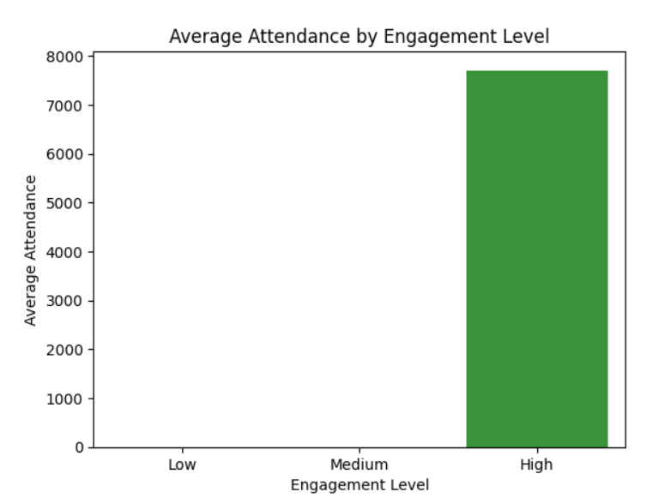

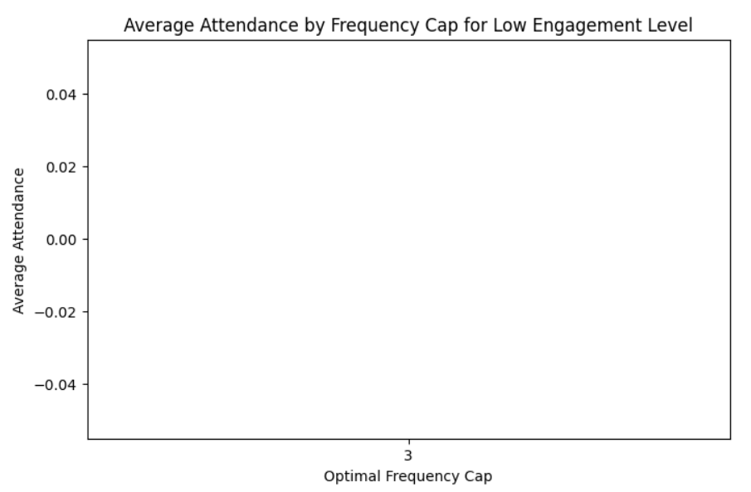

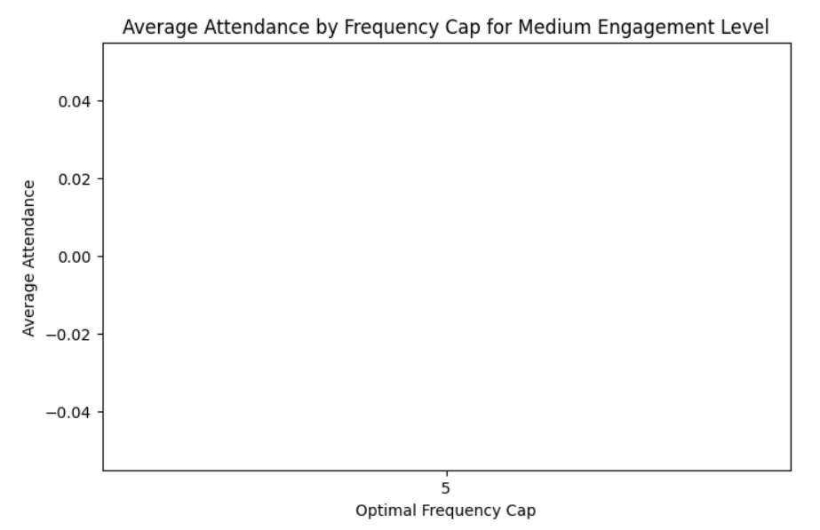

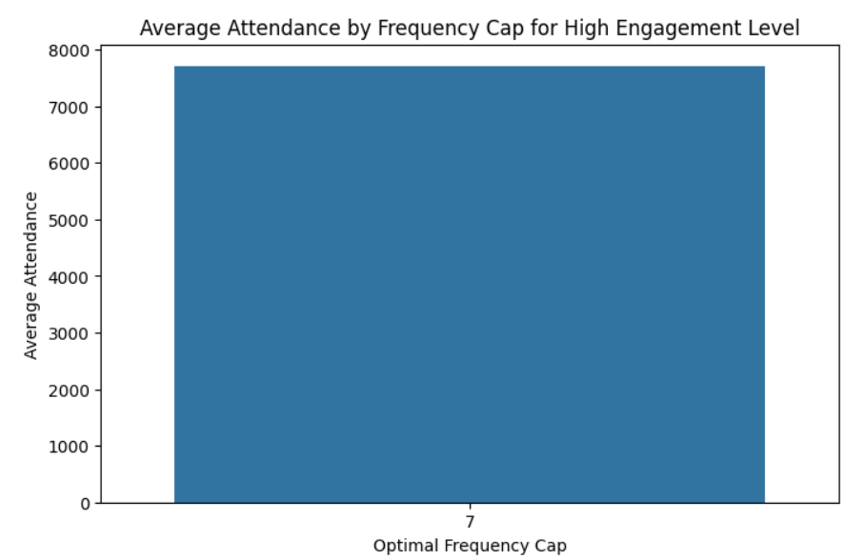

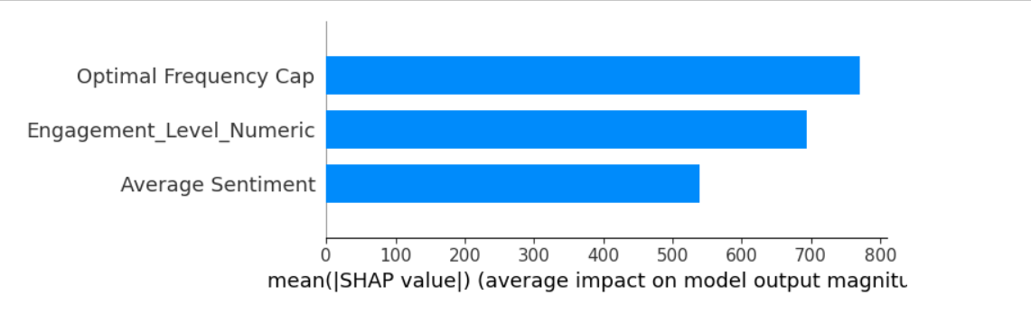

**Progress :**

· **Accomplishments**:

* Successfully completed data preprocessing and EDA, gaining insights into the engagement factors that affect product placement effectiveness.
* Developed and evaluated preliminary models to predict Average Attendance.

· **Metrics**:

* **Model R² Score**: Initial Linear Regression model had moderate R²; Random Forest model has shown improvements with cross-validation scores.
* **Feature Importances**: Found Engagement Level and Optimal Frequency Cap to be significant predictors of Average Attendance.

# Challenges and Solutions :

· **Challenges Faced**: Initial challenges included aligning available data columns with analysis needs and handling potential multicollinearity among features.

· **Solutions Implemented**: Used encoding for categorical variables and applied Random Forest for feature selection, helping mitigate multicollinearity issues.

**Next Steps :**

· **Upcoming Tasks**:

* Finalize hyperparameter tuning for the Random Forest model to improve prediction accuracy.
* Implement SHAP analysis to interpret model results and understand how each factor influences attendance.

· **Goals**:

* Complete the analysis with refined models and feature importance insights.
* Develop a summary report with visualizations for key findings.

# Conclusion :

### Summary:

# The analysis so far reveals that Engagement Level and Optimal Frequency Cap are significant in predicting the effectiveness of product placements in terms of attendance. Further model tuning and SHAP analysis will help enhance interpretability and provide actionable insights.

# **Acknowledgments**: Thank the audience for their time and attention.